第三次上机：构造函数和析构函数

#include<iostream>

using namespace std;

class Coordinate

{

public:

Coordinate()

{

times=2;

cout<<"Coordinate construction1 called!"<<endl;

}

Coordinate (int times1)

{

times=times1;

cout<<"Coordinate construction2 called!"<<endl;

}

~Coordinate()

{

cout<<"Coordinate destruction called!"<<endl;

}

void InputCoord()

{

for(int i=0;i<times;i++)

{

cout<<"Please Input x:"<<endl;

cin>>Coord[i][1];

cout<<"Please Input y:"<<endl;

cin>>Coord[i][2];

}

}

void ShowCoord()

{

cout<<"The coord is:"<<endl;

for(int i=0;i<times;i++)

{

cout<<"("<<Coord[i][1]<<","<<Coord[i][2]<<")"<<endl;

}

}

void ShowAvgCoord()

{

float avgx=0;

float avgy=0;

for(int i=0;i<times;i++)

{

avgx=avgx+Coord[i][1];

avgy=avgy+Coord[i][2];

}

avgx=avgx/times;

avgy=avgy/times;

cout<<"The AVG coord is:"<<endl;

cout<<"("<<avgx<<","<<avgy<<")"<<endl;

}

Private:

fioat Coord[100][100];

int times;

};

int main()

{

Coordinate x;

x.InputCoord();

x.ShowCoord();

x.ShowAvgCoord();

return 0;

}

#include<iostream>

#include<string>

using namespace std;

class Score

{

public:

Score()

{times=2;}

Score(int times1;)

{times=times1;}

void InputNameAndScore()

{

for(int i=0;i<times;i++)

{

cout<<"请输入学生姓名:"<<endl;

cin>>Name[i];

cout<<"请输入科目A成绩:"<<endl;

cin>>SScore[i][1];

cout<<"请输入科目B成绩:"<<endl;

cin>>SScore[i][2];

cout<<"请输入科目C成绩:"<<endl;

cin>>SScore[i][3];

}

}

void ShowNameAndScore()

{

for(int i=0;i<times;i++)

{

cout<<"姓名:"<<Name[i]<<"科目A成绩:"<<SScore[i][1]<<"科目B成绩:"<<SScore[i][2]<<"科目C成绩:"<<SScore[i][3]<<endl;

}

}

void ShowStdentAvgAndScore(int Sid)

{

fioat avg=0;

avg=(SScore[Sid][1]+SScore[Sid][2]+SScore[Sid][3])/3;

cout<<"姓名:"<<Name[Sid]<<"平均成绩；"<<avg<<endl;

}

void ShowClassAvgScore(string ClassName)

{

int Cid;

float avg=0;

if(ClassName=="A") Cid=1;

if(ClassName=="B") Cid=2;

if(ClassName=="C") Cid=3;

for(int i=0;i<times;i++)

{avg=avg+SScore[i][Cid];

avg=avg/times;

cout<<"课程名称："<<ClassName<<"平均成绩："<<avg<<endl;

}

void OrderScore(string ClassName)

{

int Cid;

if(ClassName=="A") Cid=1;

if(ClassName=="B") Cid=2;

if(ClassName=="C") Cid=3;

for(int i=0;i<times;i++)

{SScore1[i]=SScore[i][Cid];}

for(i=0;i<times;i++)

{Name1[i]=Name[i];}

for(i=1;i<times;i++)

{

if(SScore1[i]=SScore1[i-1])

{

float temp=SScore1[i-1];

SScore1[i-1]=SScore1[i];

SScore1[i]=temp;

string temp1;

temp1=Name1[i-1];

Name1[i-1]=Name1[i];

Name1[i]=temp1;

}

}

cout<<"课程名称："<<ClassName<<endl;

for(i=0;i<times;i++)

{

cout<<"姓名："<<Name1[i]<<"成绩："<<SScore1[i]<<endl;

}

}

private:

float SScore[100][3],SScore1[100];

string Name[100],Name1[100];

int times;

};

int main()

{

Score x;

x.InputNameAndScore();

x.ShowNameAndScore();

x.ShowstdentAvgScore(1);

x.ShowClassAvgScore("A");

x.OrderScore("B");

return 0;

}

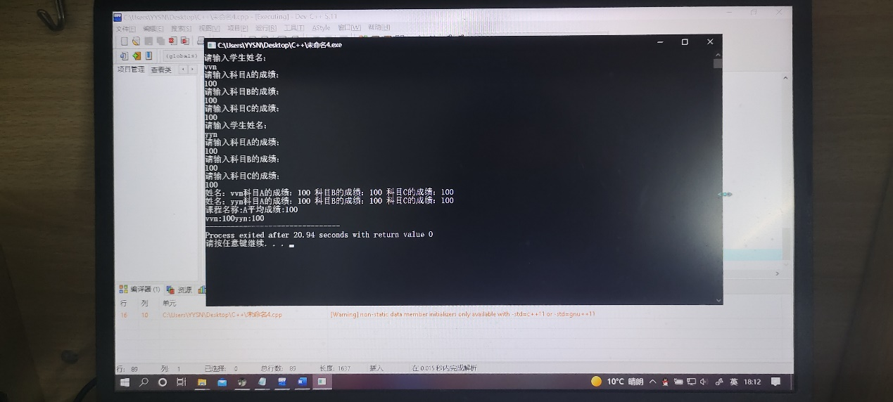

这个程序涉及到的变量较多，而且内容复杂；我觉得应该理清关系之后再进行程序设计。